2019 Fall 1 Submission Resources

Found in https://csis.fcmat.org/resources-repository:
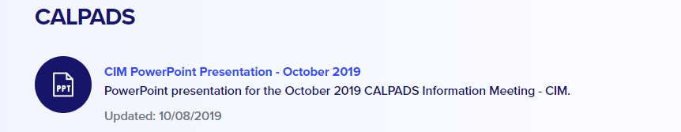

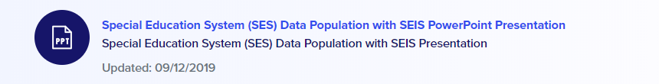

Found in the online CALPADS User Manual https://documentation.calpads.org/:
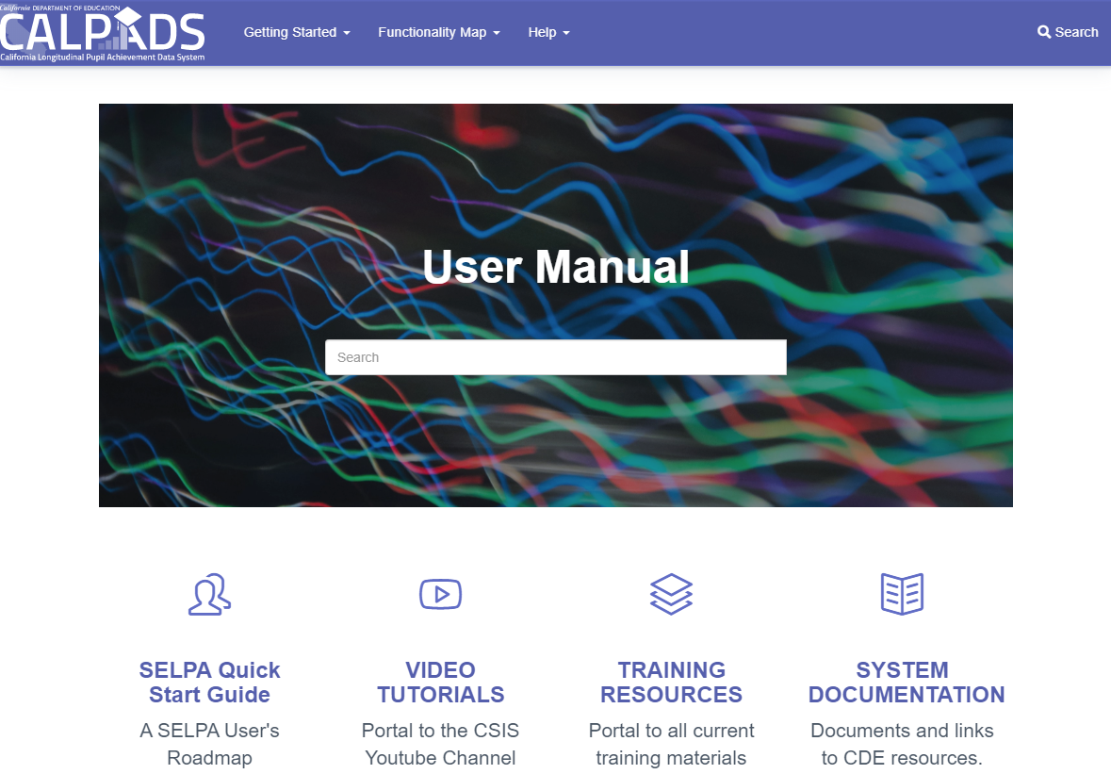

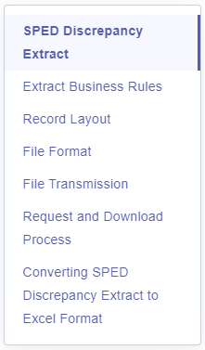
SPED Discrepancy Extract

An LEA user may request an extract of the SPED Discrepancies for a specific SPED batch submission. The data in the file may be used locally on the user’s personal computing system for analysis and resolution of any School of Attendance, School of Attendance NPS, or demographic data mismatch between what is in CALPADS vs what is in the local Special Education System (SES).

File Transmission
An LEA user may request a SPED Discrepancy Extract file for the SPED record type through the CALPADS portal. The SPED Discrepancy Extract function will allow an authorized user to specify selection criteria where applicable and request a file be created by the CALPADS application. The generated file will be available for download through CALPADS. The file will not be transmitted via email.

SPED Discrepancy
The SPED Discrepancy extract result when converted to Excel does not have header names to identify each column. You can download the SPED Discrepancy Extract Template and import your data to the template and use it as reference to what column has a discrepancy. Please note that anything beyond the red line in the discrepancy extract will be the section where possible discrepancies occur. Only columns with discrepancy will show values.

Sample Discrepancy Extract
Below is an example of a discrepancy extract converted to excel with the headers included.
